Read the Integrative Case 2 and answer questions a - g
Follow these instructions for completing and submitting your assignment:
- Please do all work in Excel. Do not submit Word files or *.pdf files.
- Submit a single spreadsheet file for this assignment. Do not submit multiple files.
- Place each problem on a separate spreadsheet tab.
- Label all inputs and outputs and highlight your final answer.
- Follow the directions in “Guidelines for Developing Spreadsheets.”

Guidelines for Developing Spreadsheets

It is important to develop spreadsheets that are clear, well-organized, and easy to read. Here are some tips that you will need to assist with your assignments.

- Your spreadsheet should be organized into three basic parts. Clearly label each part.
  - A title, labeling what your spreadsheet does. The title for your spreadsheets in this course can be the problem number that you are assigned. Place this in the upper left corner, in cell A1.
  - Inputs, which are given or assumed.
  - Results (Outputs) which the spreadsheet calculates.
- Provide specific labels for all inputs and outputs. Label both the variable names and the notation for the variables. Where a formula is involved, it is a good idea (but not necessary) to enter the formula to the right of the cell containing the results. I display these formulas in italics, so that they are not confused with the variable labels.
- Highlight the cell containing the final answer, using EXCEL’s yellow highlighter, which can be found on the top menu bar.
- If your spreadsheet uses a long formula, you might find it advisable to break the formula into component parts. This serves to minimize the typos that can occur when entering long formulas, as well as makes locating errors in the results easier to find. Nested parentheses are a particular problem in long formulas, and breaking up the calculations into component parts minimizes the need for nested parentheses also. In the example below, the calculations are broken into two steps; (1) the percentage changes in price and quantity demanded, and (2) the final elasticity calculation using these intermediate results.
- Don’t forget to place each homework problem on a separate spreadsheet tab. Label these tabs with the problem number for easy identification.

A sample spreadsheet reflecting these points is below.

Calculating Price Elasticity of Demand
Inputs:
Original Price (P1) | $10.00
New Price (P2) | $12.00
Original Quantity Sold (Q1) | 950
New Quantity Sold (Q2) | 900
Results:
% change in price (decimal form) | 0.2000 | =(p2-p1)/p1
% change in quantity demanded (decimal form) | -0.05263 | =(q2-q1)/q1
price elasticity of demand | -0.26316

Integrative Case 2
Track Software, Inc.
Seven years ago, after 15 years in public accounting, Stanley Booker, CPA,
resigned his position as manager of cost systems for Davis, Cohen, and O’Brien
Public Accountants and started Track Software, Inc. In the 2 years preceding his
departure from Davis, Cohen, and O’Brien, Stanley had spent nights and weekends
developing a sophisticated cost-accounting software program that became Track’s
initial product offering. As the firm grew, Stanley planned to develop and expand
the software product offerings, all of which would be related to streamlining the
accounting processes of medium- to large-sized manufacturers.
Although Track experienced losses during its first 2 years of operation—2009
and 2010—its profit has increased steadily from 2011 to the present (2015). The
firm’s profit history, including dividend payments and contributions to retained
earnings, is summarized in Table 1.
Stanley started the firm with a $100,000 investment: his savings of $50,000 as
equity and a $50,000 long-term loan from the bank. He had hoped to maintain his
initial 100 percent ownership in the corporation, but after experiencing a $50,000
loss during the first year of operation (2009), he sold 60 percent of the stock to a
group of investors to obtain needed funds. Since then, no other stock transactions
have taken place. Although he owns only 40 percent of the firm, Stanley actively
manages all aspects of its activities; the other stockholders are not active in management
of the firm. The firm’s stock was valued at $4.50 per share in 2014 and at
$5.28 per share in 2015.
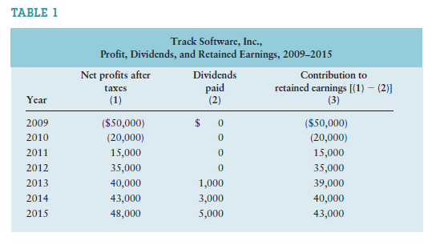
Stanley has just prepared the firm’s 2015 income statement, balance sheet, and
statement of retained earnings, shown in Tables 2, 3, and 4, along with the 2014
balance sheet. In addition, he has compiled the 2014 ratio values and industry
average ratio values for 2015, which are applicable to both 2014 and 2015 and
are summarized in Table 5. He is quite pleased to have achieved record earnings of
$48,000 in 2015, but he is concerned about the firm’s cash flows. Specifically, he
is finding it more and more difficult to pay the firm’s bills in a timely manner and
generate cash flows to investors, both creditors and owners. To gain insight into
these cash flow problems, Stanley is planning to determine the firm’s 2015 operating
cash flow (OCF) and free cash flow (FCF).
Stanley is further frustrated by the firm’s inability to afford to hire a software
developer to complete development of a cost estimation package that is believed
to have “blockbuster” sales potential. Stanley began development of this package
2 years ago, but the firm’s growing complexity has forced him to devote more of
his time to administrative duties, thereby halting the development of this product.
Stanley’s reluctance to fill this position stems from his concern that the added
$80,000 per year in salary and benefits for the position would certainly lower the
firm’s earnings per share (EPS) over the next couple of years. Although the project’s
success is in no way guaranteed, Stanley believes that if the money were spent to hire
the software developer, the firm’s sales and earnings would significantly rise once
the 2- to 3-year development, production, and marketing process was completed.
With all these concerns in mind, Stanley set out to review the various data to
develop strategies that would help ensure a bright future for Track Software. Stanley
believed that as part of this process, a thorough ratio analysis of the firm’s 2015
results would provide important additional insights.
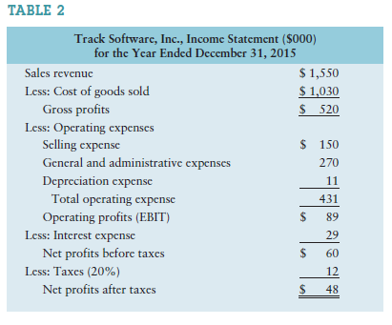
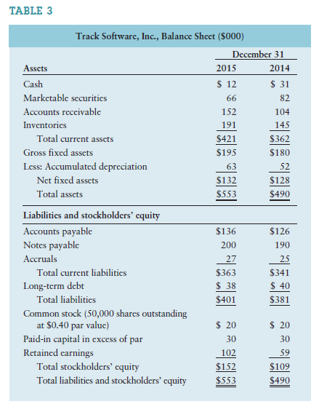
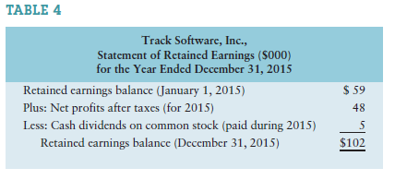
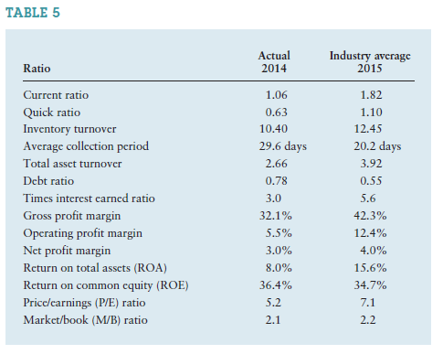
TO DO

a. (1) On what financial goal does Stanley seem to be focusing? Is it the correct
goal? Why or why not?
(2) Could a potential agency problem exist in this firm? Explain.

b. Calculate the firm’s earnings per share (EPS) for each year, recognizing that the
number of shares of common stock outstanding has remained unchanged since
the firm’s inception. Comment on the EPS performance in view of your response
in part a.

c. Use the financial data presented to determine Track’s operating cash flow (OCF)
and free cash flow (FCF) in 2015. Evaluate your findings in light of Track’s current
cash flow difficulties.

d. Analyze the firm’s financial condition in 2015 as it relates to (1) liquidity, (2) activity,
(3) debt, (4) profitability, and (5) market, using the financial statements
provided in Tables 2 and 3 and the ratio data included in Table 5. Be sure to
evaluate the firm on both a cross-sectional and a time-series basis.

e. What recommendation would you make to Stanley regarding hiring a new software
developer? Relate your recommendation here to your responses in part a.

f. Track Software paid $5,000 in dividends in 2015. Suppose that an investor approached
Stanley about buying 100% of his firm. If this investor believed that by
owning the company he could extract $5,000 per year in cash from the company
in perpetuity, what do you think the investor would be willing to pay for the firm
if the required return on this investment is 10%?

g. Suppose that you believed that the FCF generated by Track Software in 2015
could continue forever. You are willing to buy the company in order to receive
this perpetual stream of free cash flow. What are you willing to pay if you require
a 10% return on your investment?

